**A Simple Micro-Benchmarking in PYTHON**

Angel Rosin Daplas

Central Mindanao University

San Miguel, Maramag, Bukidnon

+63 9079586385

s.daplas.angel@cmu.edu.ph

3rd Author

3rd author's affiliation  
1st line of address  
2nd line of address  
Telephone number, incl. country code

3rd E-mail

**ABSTRACT**

In this paper, we present a simple Python-based micro-benchmarking experiment, focusing on measuring code performance across various devices. Our study implements a quicksort algorithm, measuring execution times under different hardware specifications to observe the performance impact. We explore the influence of factors such as CPU and memory on benchmark results.

**CCS Concepts**

• **Computing methodologies ➝ Machine learning ➝ Machine learning performance** • **Hardware ➝ Mobile and wearable devices ➝ Mobile device benchmarking** • **Software and its engineering➝ Software performance ➝ Micro-benchmarking techniques**.

**Keywords**

Micro-benchmarking; Python; Performance evaluation; Quicksort; Cross-device comparison.

# INTRODUCTION

Micro-benchmarking provides a means to measure the performance of specific code blocks, particularly useful in identifying bottlenecks and optimization opportunities. This paper explores how a Python quicksort implementation performs across different systems by measuring runtime under various hardware conditions. By running a consistent sorting workload, we can observe the impact of device specifications on the algorithm's execution time.

## 2. MICRO-BENCHMARK PROGRAM

The program used for this benchmark performs quicksort on an array of integers. To minimize garbage collection interference, gc.collect() is called before each run. Execution times were averaged over five runs on each device, reducing variability.

.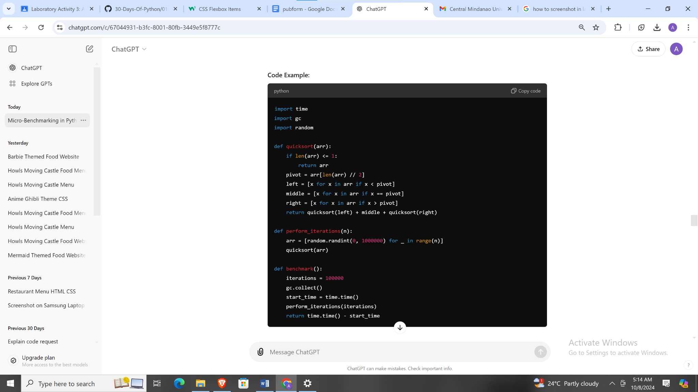

**Table 1. Benchmark Results for Samsung Desktop**

|  | **Run** | **Elapsed Time** |  |
| --- | --- | --- | --- |
|  |  | 0.69  0.64  0.64  0.60  0.66  0.65 |  |
|  |  | Similar |  |

**Table 1. Benchmark Results for Samsung Desktop**

| **Run** | **Elapsed Time (s)** |
| --- | --- |
| 1 | 0.69 |
| 2 | 0.64 |
| 3 | 0.64 |
| 4 | 0.60 |
| 5 | 0.66 |
| **Average** | **0.65** |

# TYPESET TEXT

## Normal or Body Text

SAMPLE: Permission to make digital or hard copies of all or part of this work for personal or classroom use is granted without fee provided that copies are not made or distributed for profit or commercial advantage and that copies bear this notice and the full citation on the first page. To copy otherwise, or republish, to post on servers or to redistribute to lists, requires prior specific permission and/or a fee.

*Conference’10*, Month 1–2, 2010, City, State, Country.

Copyright 2010 ACM 1-58113-000-0/00/0010 …$15.00.

DOI: http://dx.doi.org/10.1145/12345.67890

Please use a 9-point Times Roman font, or other Roman font with serifs, as close as possible in appearance to Times Roman in which these guidelines have been set. The goal is to have a 9-point text, as you see here. Please use sans-serif or non-proportional fonts only for special purposes, such as distinguishing source code text. If Times Roman is not available, try the font named Computer Modern Roman. On a Macintosh, use the font named Times. Right margins should be justified, not ragged.

## Title and Authors

The title (Helvetica 18-point bold), authors' names (Helvetica 12-point) and affiliations (Helvetica 10-point) run across the full width of the page – one column wide. We also recommend phone number (Helvetica 10-point) and e-mail address (Helvetica 12-point). See the top of this page for three addresses. If only one address is needed, center all address text. For two addresses, use two centered tabs, and so on. For more than three authors, you may have to improvise.[1]

## First Page Copyright Notice

Please leave 3.81 cm (1.5") of blank text box at the bottom of the left column of the first page for the copyright notice.

## Subsequent Pages

For pages other than the first page, start at the top of the page, and continue in double-column format. The two columns on the last page should be as close to equal length as possible.

**Table 1. Table captions should be placed above the table**

| **Graphics** | **Top** | **In-between** | **Bottom** |
| --- | --- | --- | --- |
| Tables | End | Last | First |
| Figures | Good | Similar | Very well |

## References and Citations

Footnotes should be Times New Roman 9-point, and justified to the full width of the column.

Use the “ACM Reference format” for references – that is, a numbered list at the end of the article, ordered alphabetically and formatted accordingly. See examples of some typical reference types, in the new “ACM Reference format”, at the end of this document. Within this template, use the style named *references* for the text. Acceptable abbreviations, for journal names, can be found here: <http://library.caltech.edu/reference/abbreviations/>. Word may try to automatically ‘underline’ hotlinks in your references, the correct style is NO underlining.

The references are also in 9 pt., but that section (see Section 7) is ragged right. References should be published materials accessible to the public. Internal technical reports may be cited only if they are easily accessible (i.e. you can give the address to obtain the report within your citation) and may be obtained by any reader. Proprietary information may not be cited. Private communications should be acknowledged, not referenced (e.g., “[Robertson, personal communication]”).

## Page Numbering, Headers and Footers

Do not include headers, footers or page numbers in your submission. These will be added when the publications are assembled.

# FIGURES/CAPTIONS

Place Tables/Figures/Images in text as close to the reference as possible (see Figure 1). It may extend across both columns to a maximum width of 17.78 cm (7”).

Captions should be Times New Roman 9-point bold. They should be numbered (e.g., “Table 1” or “Figure 2”), please note that the word for Table and Figure are spelled out. Figure’s captions should be centered beneath the image or picture, and Table captions should be centered above the table body.

# SECTIONS

The heading of a section should be in Times New Roman 12-point bold in all-capitals flush left with an additional 6-points of white space above the section head. Sections and subsequent sub- sections should be numbered and flush left. For a section head and a subsection head together (such as Section 3 and subsection 3.1), use no additional space above the subsection head.

## Subsections

The heading of subsections should be in Times New Roman 12-point bold with only the initial letters capitalized. (Note: For subsections and subsubsections, a word like *the* or *a* is not capitalized unless it is the first word of the header.)

### Subsubsections

The heading for subsubsections should be in Times New Roman 11-point italic with initial letters capitalized and 6-points of white space above the subsubsection head.

#### Subsubsections

The heading for subsubsections should be in Times New Roman 11-point italic with initial letters capitalized.

#### Subsubsections

The heading for subsubsections should be in Times New Roman 11-point italic with initial letters capitalized.

# ACKNOWLEDGMENTS

Our thanks to ACM SIGCHI for allowing us to modify templates they had developed.

# REFERENCES

1. Bowman, M., Debray, S. K., and Peterson, L. L. 1993. Reasoning about naming systems. *ACM Trans. Program. Lang. Syst.* 15, 5 (Nov. 1993), 795-825. DOI= <http://doi.acm.org/10.1145/161468.16147>.
2. Ding, W. and Marchionini, G. 1997. *A Study on Video Browsing Strategies*. Technical Report. University of Maryland at College Park.
3. Fröhlich, B. and Plate, J. 2000. The cubic mouse: a new device for three-dimensional input. In *Proceedings of the SIGCHI Conference on Human Factors in Computing Systems* (The Hague, The Netherlands, April 01 - 06, 2000). CHI '00. ACM, New York, NY, 526-531. DOI= <http://doi.acm.org/10.1145/332040.332491>.
4. Tavel, P. 2007. *Modeling and Simulation Design*. AK Peters Ltd., Natick, MA.
5. Sannella, M. J. 1994. *Constraint Satisfaction and Debugging for Interactive User Interfaces*. Doctoral Thesis. UMI Order Number: UMI Order No. GAX95-09398., University of Washington.
6. Forman, G. 2003. An extensive empirical study of feature selection metrics for text classification. *J. Mach. Learn. Res.* 3 (Mar. 2003), 1289-1305.
7. Brown, L. D., Hua, H., and Gao, C. 2003. A widget framework for augmented interaction in SCAPE. In *Proceedings of the 16th Annual ACM Symposium on User Interface Software and Technology* (Vancouver, Canada, November 02 - 05, 2003). UIST '03. ACM, New York, NY, 1-10. DOI= <http://doi.acm.org/10.1145/964696.964697>.
8. Yu, Y. T. and Lau, M. F. 2006. A comparison of MC/DC, MUMCUT and several other coverage criteria for logical decisions. *J. Syst. Softw.* 79, 5 (May. 2006), 577-590. DOI= <http://dx.doi.org/10.1016/j.jss.2005.05.030>.
9. Spector, A. Z. 1989. Achieving application requirements. In *Distributed Systems*, S. Mullender, Ed. ACM Press Frontier Series. ACM, New York, NY, 19-33. DOI= <http://doi.acm.org/10.1145/90417.90738>.

1. If necessary, you may place some address information in a footnote, or in a named section at the end of your paper.